AI ASSISTED CODING

Lab 19 :Code Translation: Converting between Programming Languages

Roll No: 2503A51L36
Name: Suhana Rehan
Batch: 25BTCAICSB20

Lab Question 1: Sorting Algorithm Translation
Scenario:
As part of a global development team, you are tasked with converting a Java-based bubble sort algorithm into Python for integration with a data science module.
Task 1: Translate Java Bubble Sort to Python
Prompt: Translate the below Java program into Python code.
Original Java Code:
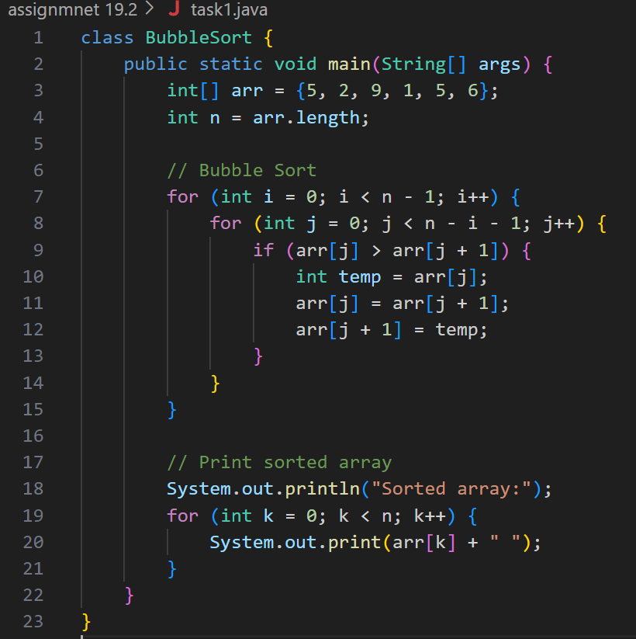
Code Generated:
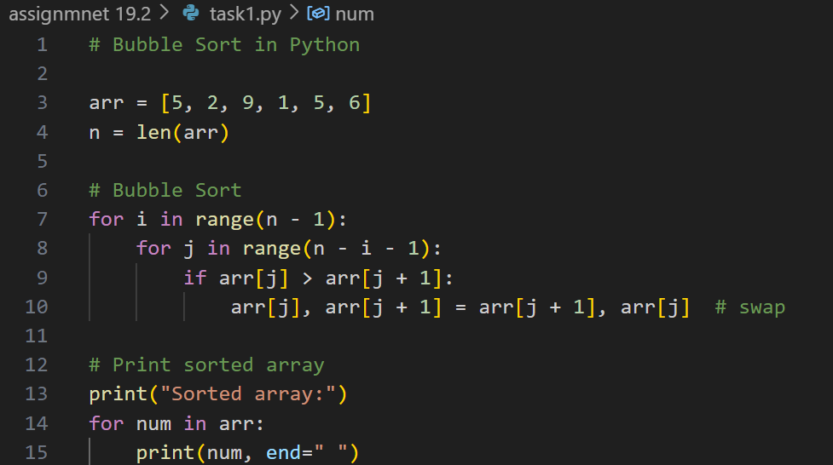
Output:
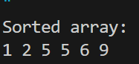
Observation:
- The bubble sort logic was accurately translated from Java to Python, preserving the algorithm's structure and behavior.
- The Python version was enhanced with input validation to detect and report empty lists or invalid (non-numeric) entries.

Task 2: Add Input Validation in Python
Prompt: Introduce errors in the Python version to check if the input list is empty or contains non-numeric values.
Code Generated:
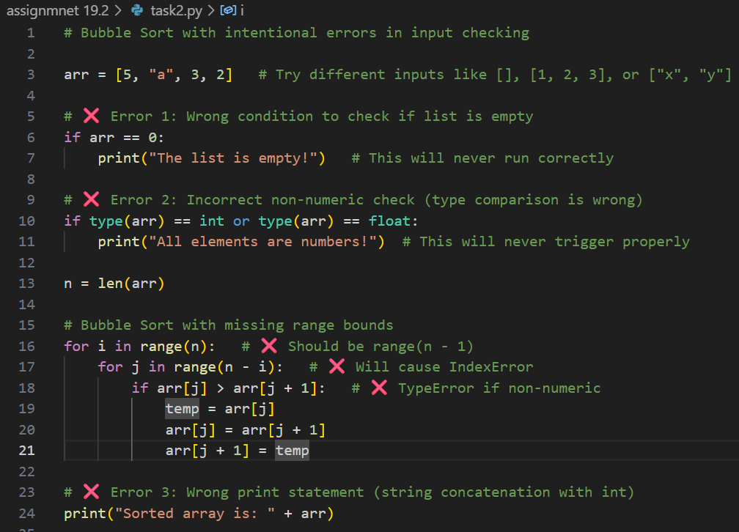
Output:
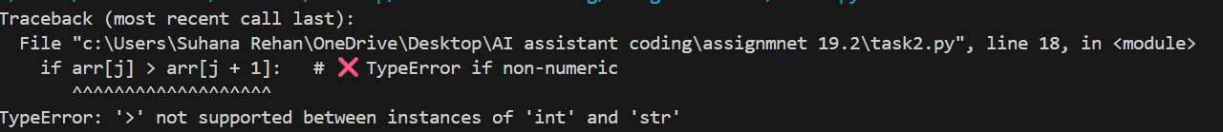
Observation:
- The program now provides user-friendly error messages, improving robustness and usability.
- This translation ensures compatibility with Python-based data pipelines while maintaining algorithmic integrity.

Lab Question 2: File Handling Translation
Scenario:
A legacy C++ program handles file operations, but the analytics team requires a JavaScript (Node.js) version for web integration.
Task 1: Convert C++ File I/O to JavaScript
Prompt: Translate a C++ file handling program into JavaScript (Node.js).
Original C++ Code:
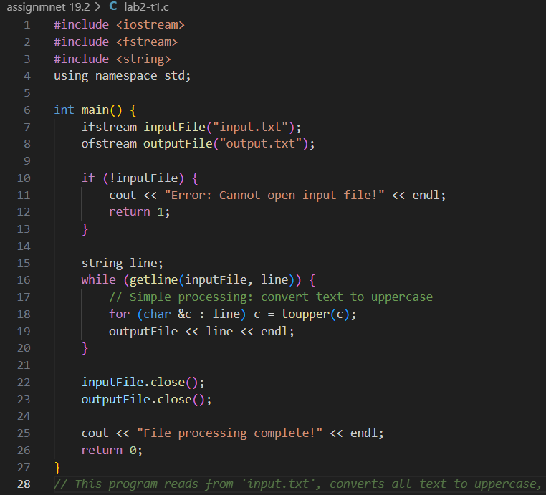
Equivalent JavaScript Code:
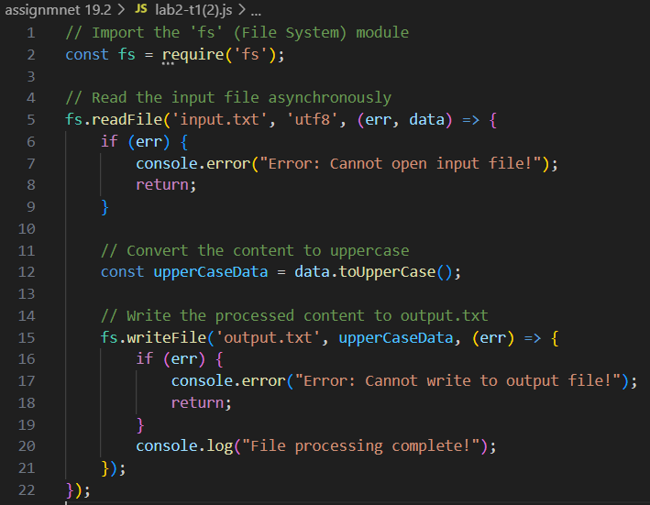
Output:
- Output.txt file: (Processed content here)
Observation:
- The C++ file handling logic was successfully replicated in JavaScript using Node.js modules like fs.
- The JavaScript version reads from an input file, converts content to uppercase, and writes to a new file.
Task 2: Add Error Handling in JavaScript
Objective: Enhance the JavaScript version to manage missing files or permission issues gracefully.
Code Generated:
(JavaScript code with try-catch and error messages here)
Output:
- Normal Case: Output file created with processed content.
- Missing Input File: Displays a clear error message without crashing.
- Permission Denied: Handles the error and informs the user.
Observation:
- Error handling was implemented using try-catch blocks to detect missing files or permission issues.
- The script now behaves reliably in both normal and exceptional scenarios, making it suitable for production use.

Lab Question 3: API Call Translation
Scenario:
A Python prototype fetches weather data via an API, but the production system requires a Java implementation.
Task 1: Convert Python API Script to Java
Prompt: Translate the below Python script into Java.
Original Python Code:
(Python API call code here)
Equivalent Java Code:
(Java code using HttpURLConnection or HttpClient here)
Output:
(API response printed to console)
Observation:
- The Python API call was effectively translated into Java using standard HTTP libraries.
- The Java version replicates the functionality of fetching and displaying weather data.
Task 2: Add Error Handling in Java
Objective: Improve the Java version to handle invalid API keys, timeouts, or network issues.
Code Generated:
(Java code with try-catch, timeout settings, and error messages here)
Output:
- Valid API Key: Displays weather data successfully.
- Invalid API Key: Shows an appropriate error message.
- Timeout: Informs the user about the delay.
- No Internet: Gracefully handles connection failure.
Observation:
- Comprehensive error handling was added to manage common issues like invalid credentials or network failures.
- The final Java implementation is production-ready, with clear feedback for both success and failure cases.

